**Assignment 5**

1. Consider a database DB with relations R1 and R2. The relation R1 contains tuples t1 and t2 and the relation R2 contains tuples t3, t4, and t5. Assume that the database DB, relations, and tuples form a hierarchy of lockable database elements. Explain the sequence of lock requests and the response of the locking scheduler to the following schedule. You may assume all lock requests occur just before they are needed, and all unlocks occur at the end of the transaction.

• T1:R(t1), T2:W(t2), T2:R(t3), T1:W(t4)

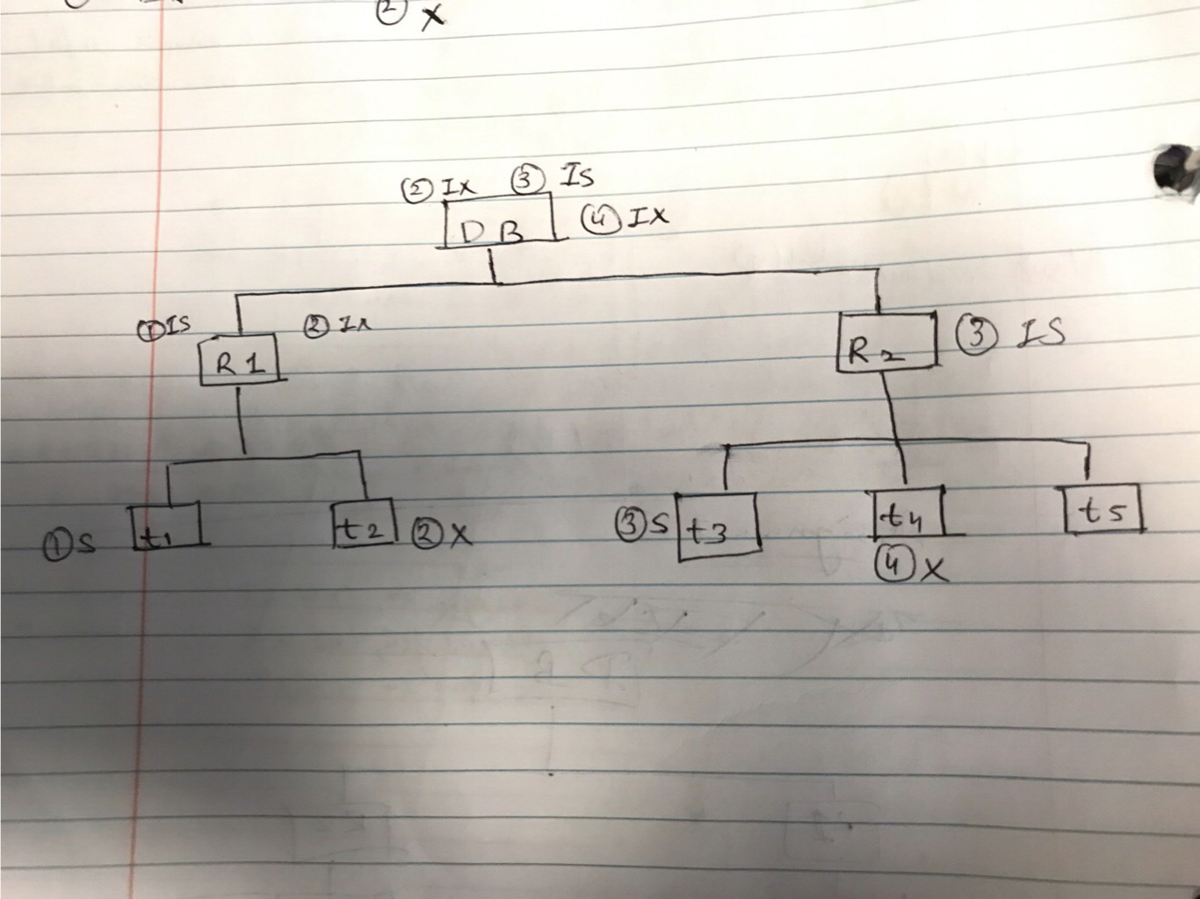

The first step puts a shared lock (**S**) on **t1** from **R1** and puts an intension shared (**IS**) lock on Relation 1 (**R1**), for the second transaction we get an exclusive lock (**X**) on **t2**, an intension exclusive (**IX**) on **R1** and also an **IX** lock on **DB**. In step 3 we give a **S** lock on **t3** and **IS** locks to **R2** and **DB** then it releases the locks at the end of the transactions. In step 4, we get a **X** lock on **t4** which also gives an **IX** lock to **DB** and then releases all the locks.

1. What are the maximum degrees of consistency for T1 and T2 in this schedule? You must find the maximum degrees of consistency for T1 and T2 that makes this schedule possible. The degree of consistency for T1 may be different from the degree of consistency of T2.

* The maximum degree of consistency in T1 is degree 2 ,since there is a conflict of write X in T1 and T2, and the maximum number of degree in T2 is degree 1, since there are dirty reads on step 4.